**St. Francis Institute of Technology**

**Department of Computer Engineering**

**Academic Year: 2021-2022 Semester: VIII**

**Subject: Cloud Computing Lab Class / Branch / Division: BE/CMPN/A**

Name :-Rebecca Dias Roll Number:18

**Experiment No: 02**

**Aim**: Implement Infrastructure as a Service

**Theory:**

1. Prepare a detailed study of Infrastructure as a Service

Infrastructure as a service (IaaS) is a type of cloud computing service that offers essential compute, storage and networking resources on demand, on a pay-as-you-go basis. IaaS is one of the four types of cloud services, along with software as a service (SaaS), platform as a service (PaaS) and serverless.

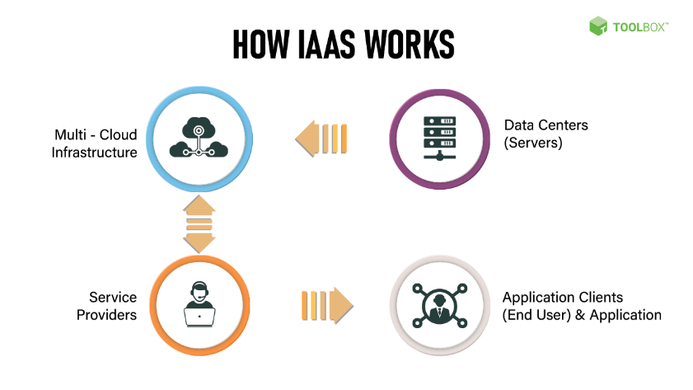

IaaS lets you bypass the cost and complexity of buying and managing physical servers and datacentre infrastructure. Each resource is offered as a separate service component and you only pay for a particular resource for as long as you need it. A cloud computing service provider like Azure manages the infrastructure, while you purchase, install, configure and manage your own software—including operating systems, middleware and applications.

2. Advantages and Limitation of IaaS

*Advantages*:

1. Cost Effective

IaaS is most economical option for businesses since it eliminates the cost of infrastructure. There is no need to purchase hardware as well as other networking equipments. And also, IaaS follows pay-as-you-go pricing scheme. Meaning, the users must spend only for what they use. The expenses are involved only at monthly level.

2. Scalability

When scaling an IaaS solution, it does not require investment in the hardware. The reason for this is the presence of cloud resources in unlimited quantity. As per the company's requirement, the IaaS allows it to be scaled up and down. As a result, businesses can save time as well as money. Once the usage of services are over, the users could scale down the solution.

3. Reliability

Reliability of data in IaaS is present to a very high extent. It is able to recover from worst case scenarios. This is because the resources of IaaS is present across various servers. Even if one server encounters problems, the remaining servers could deliver the resources without disruptions.

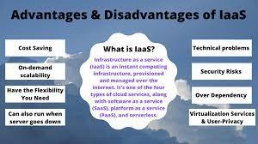

*Disadvantages:*

1. Security

Users in IaaS does not have the control of infrastructure. The security of the infrastructure is in the hands of the provider. Sometimes the level of security provided may not be adequate. As a result, it could expose your system to hacks and vulnerabilities. In this case, the businesses must be willing to accept the loss.

2. Control

The entire administration of the IaaS is taken care by the provider. While this could be a stress relief for the users, this can leave important part of controlling to the provider. Such as the users have no control over data and software. Under these conditions, the provider needs to make sure that the data as well as services are secure.

3. Customization

Customization is not an easy task in IaaS since it is based on virtualization services. This is because there is very less number of options for customization. As a result, the user privacy offered is not greater as it is with other solutions.

3. Study security issues in IaaS

* Data Leaks

Data in the cloud is exposed to the same threats as traditional infrastructures. Due to the large amount of data, platforms of cloud providers become an attractive target for attackers. Data leaks can lead to a chain of unfortunate events for IT companies and infrastructure as a service (IaaS) providers.

* Compromising Accounts And Authentication Bypass

Data leaks often result from insufficient attention to authentication verification. More often than not, weak passwords in conjunction with poor management of encryption keys and certificates are to blame. In addition, IT organizations are faced with problems of managing rights and permissions when users are assigned with much greater powers than they actually need. The problem can also occur when a user takes another position or leaves the company: no one is in a rush to update permissions under the new user roles. As a result, the account has rights to more features than necessary.

* Interface And API Hacking

Today, it is impossible to imagine cloud services and applications without friendly user interfaces (UIs) and application program interfaces (APIs). The security and availability of cloud services depends on reliable mechanisms of data access control and encryption. Weak interfaces become bottlenecks in matters of availability, confidentiality, integrity and security of systems and data.

* Cyberattacks

Targeted cyberattacks are common in our times. An experienced attacker, who has secured his presence in a target infrastructure, is not so easy to detect. Remote network attacks may have significant impact on the availability of infrastructure in general.

**Activity:**

1. Use AWS, to create a VM and configure it.
2. Access the created machine remotely

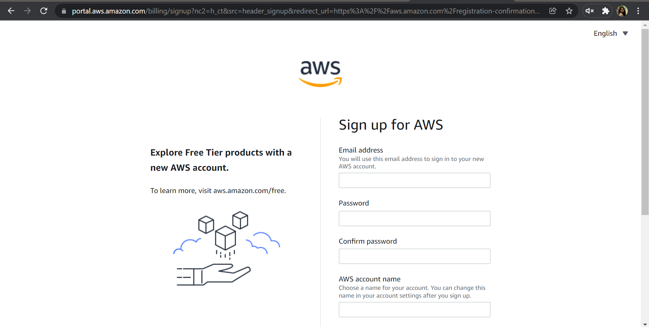

1.To demonstrate and implement IAAS service using AWS (Use t2.Micro (Free tier eligible) (instance only).

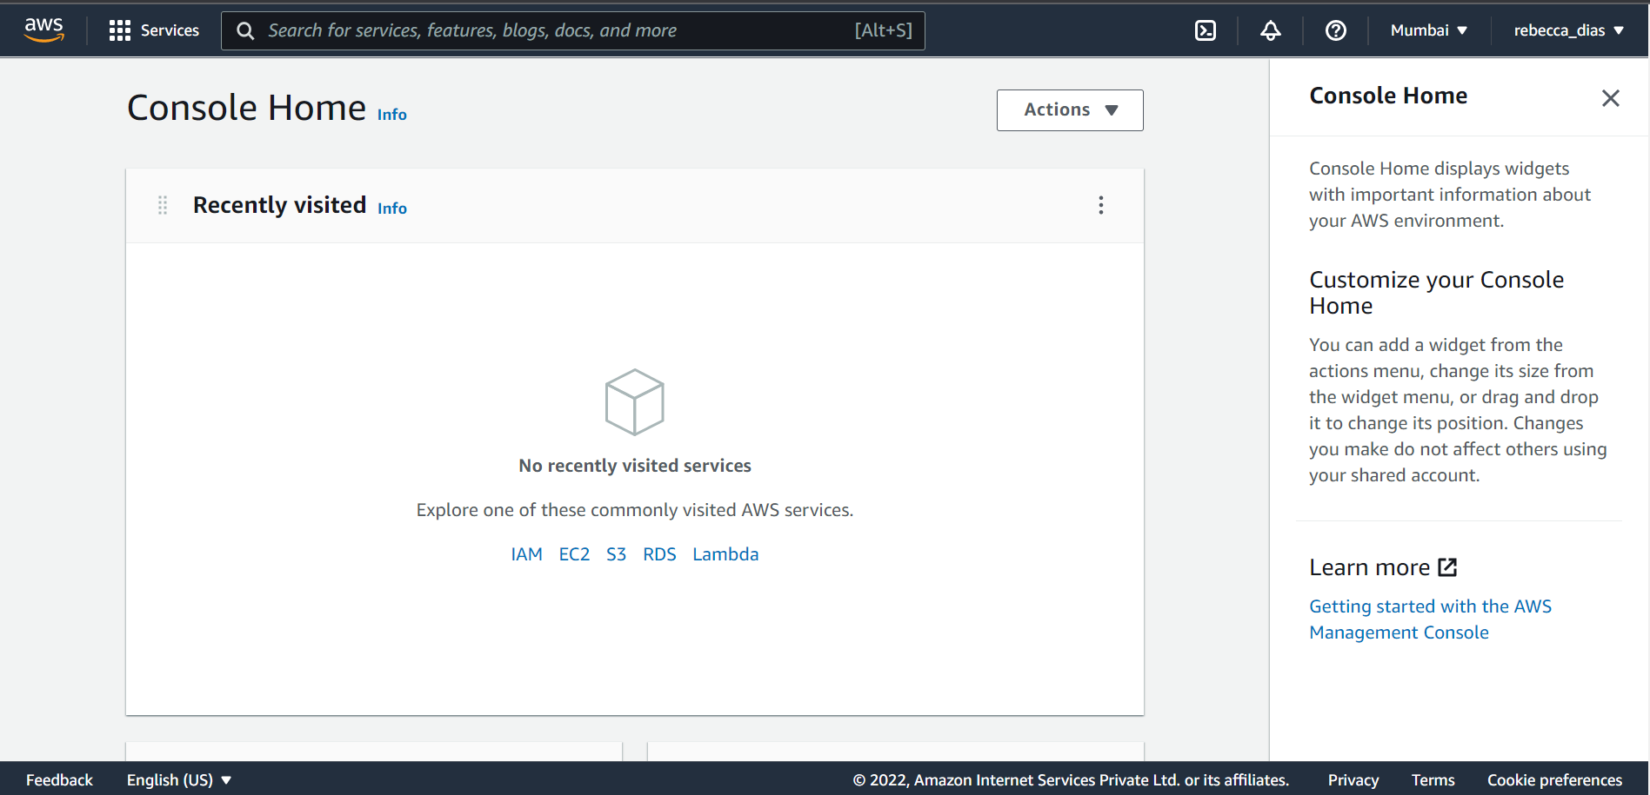

Choose Msft windows server base 2019

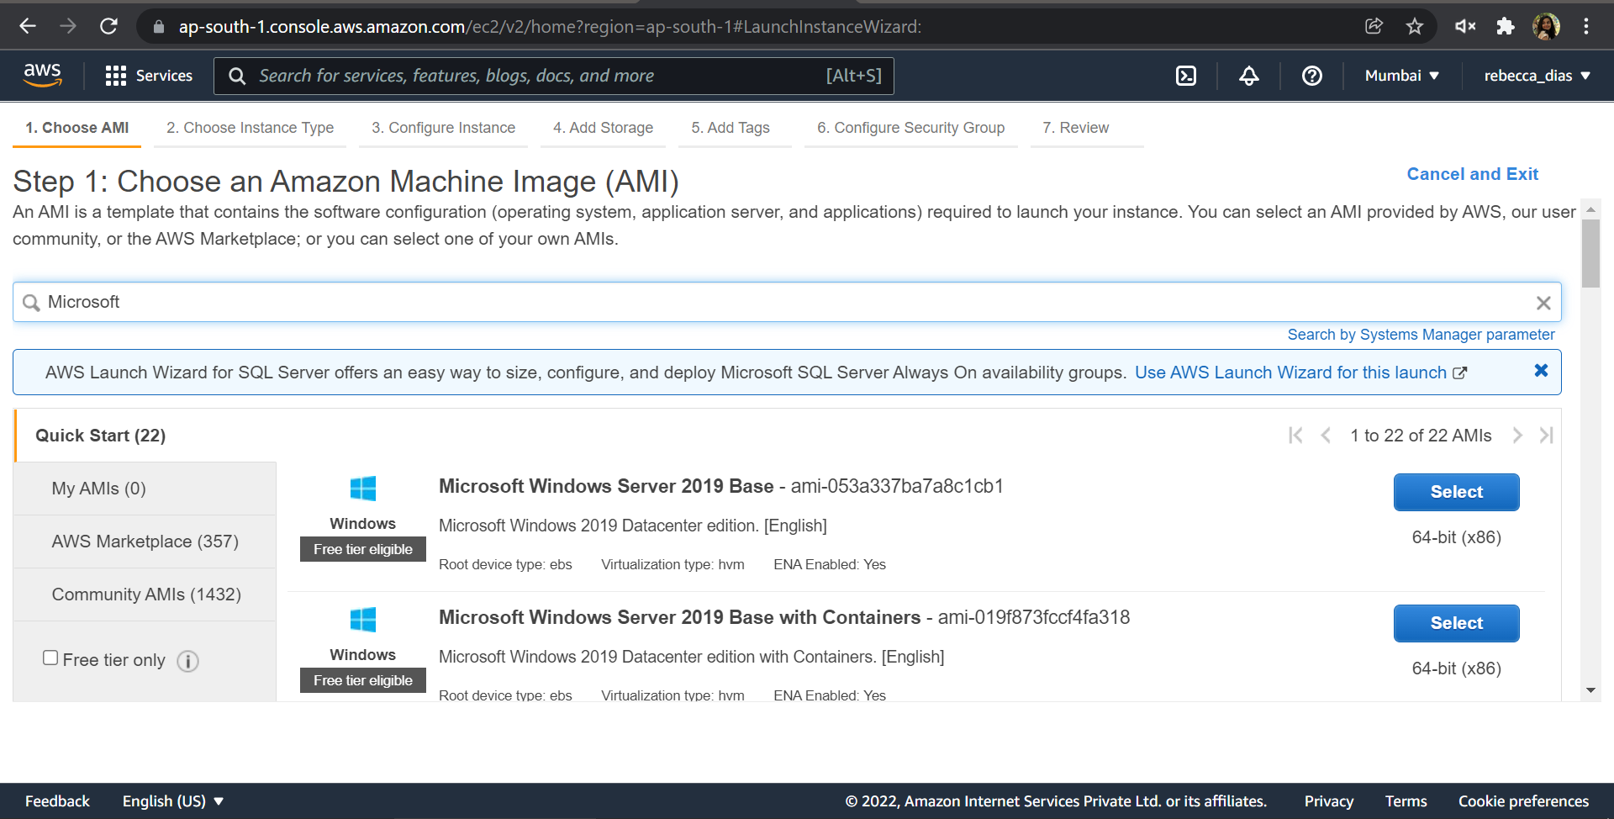

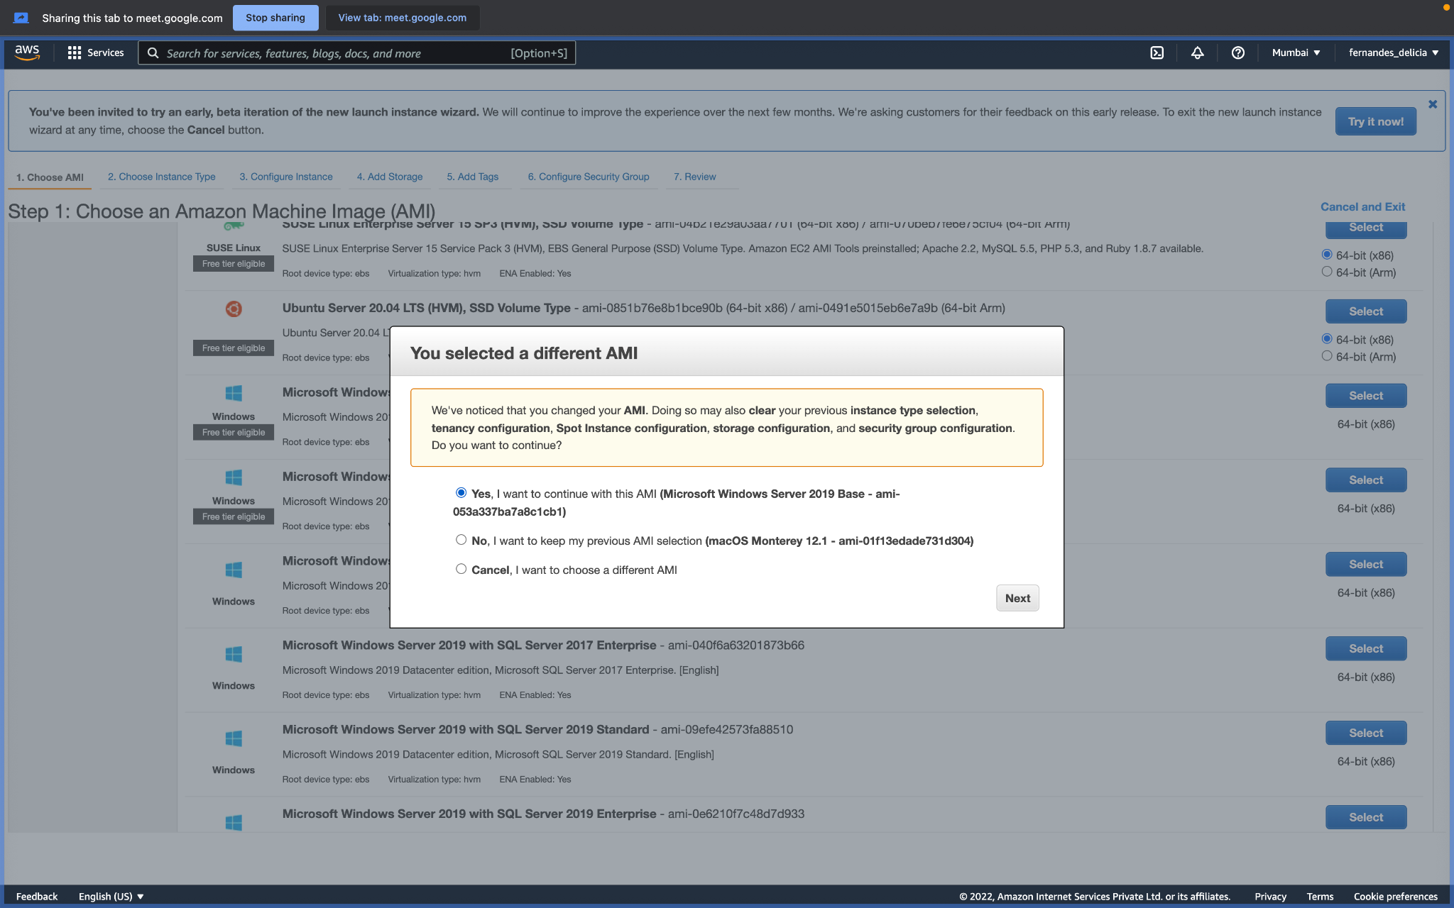

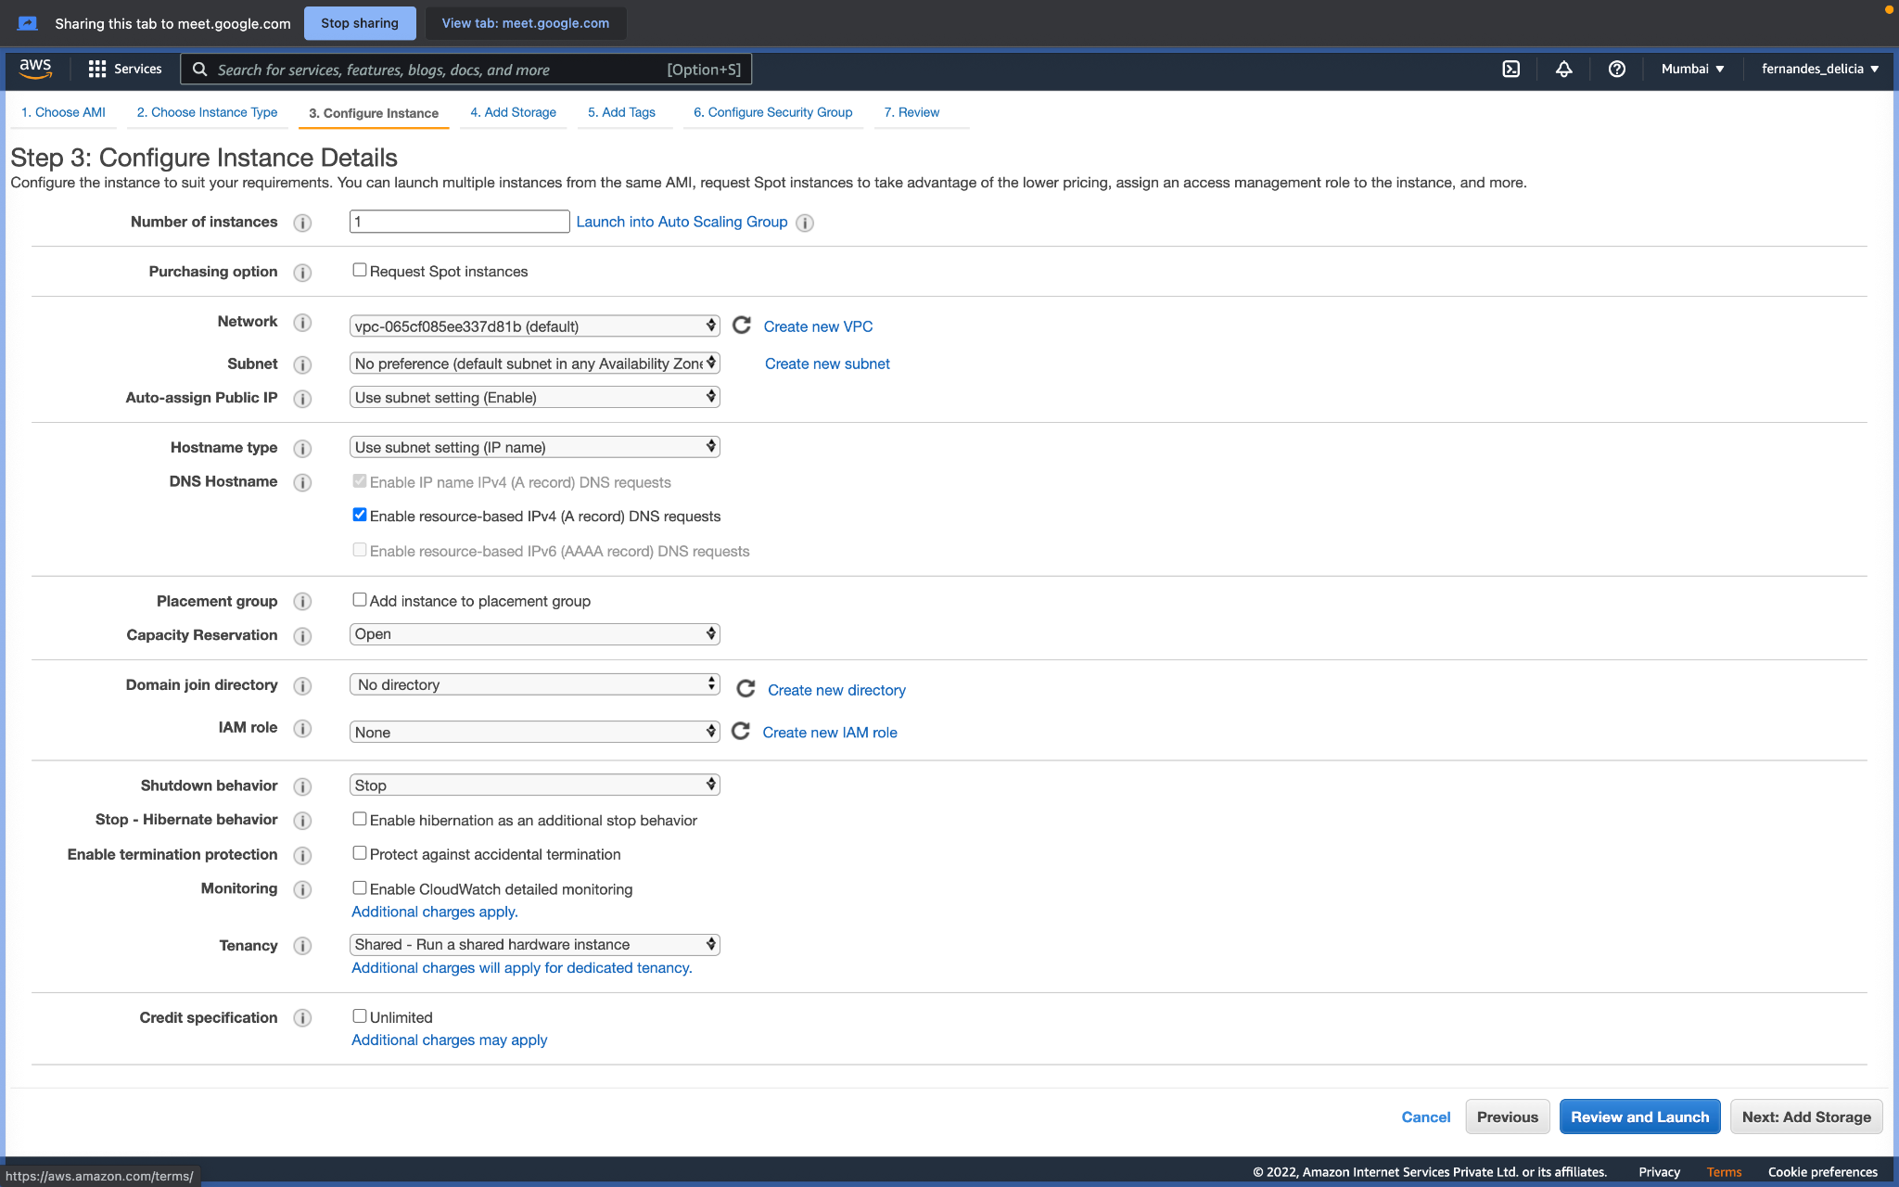

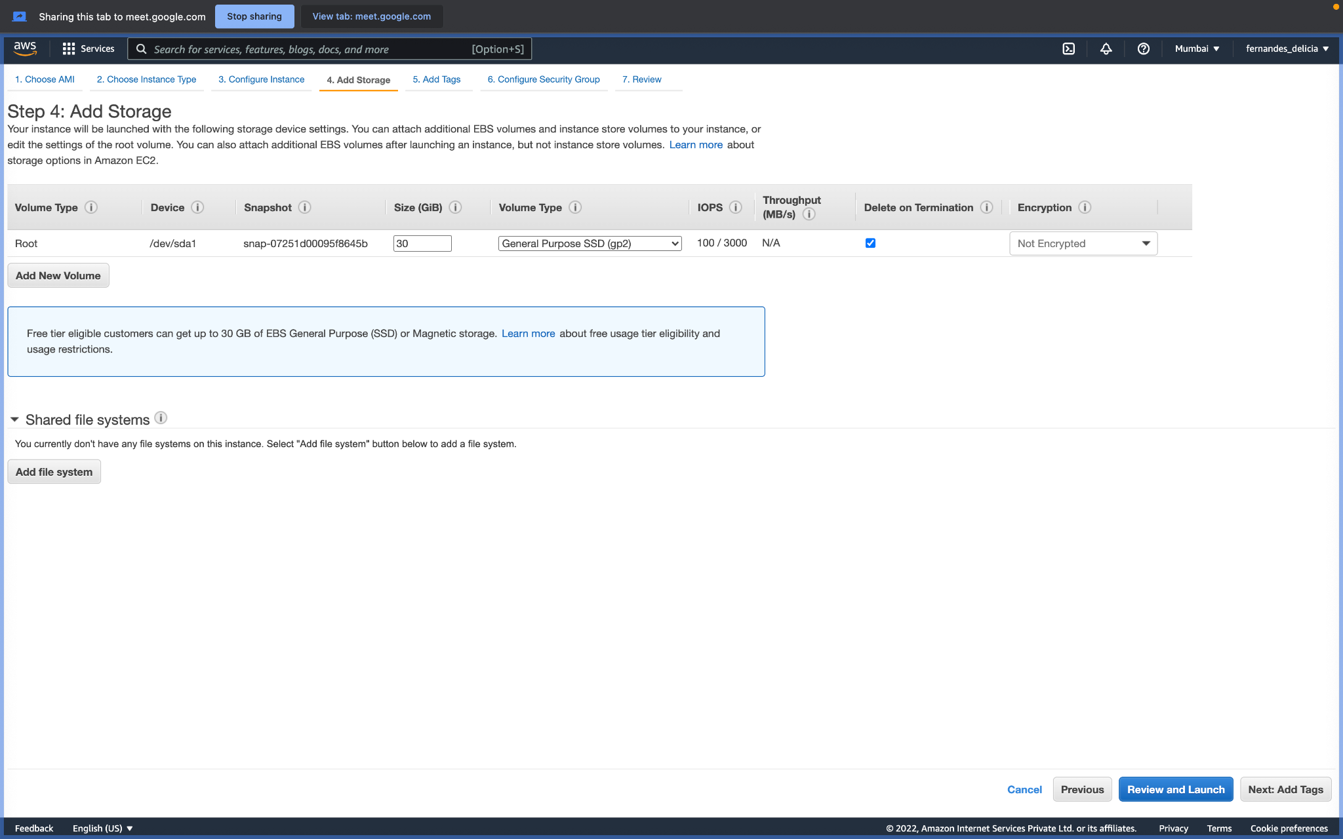

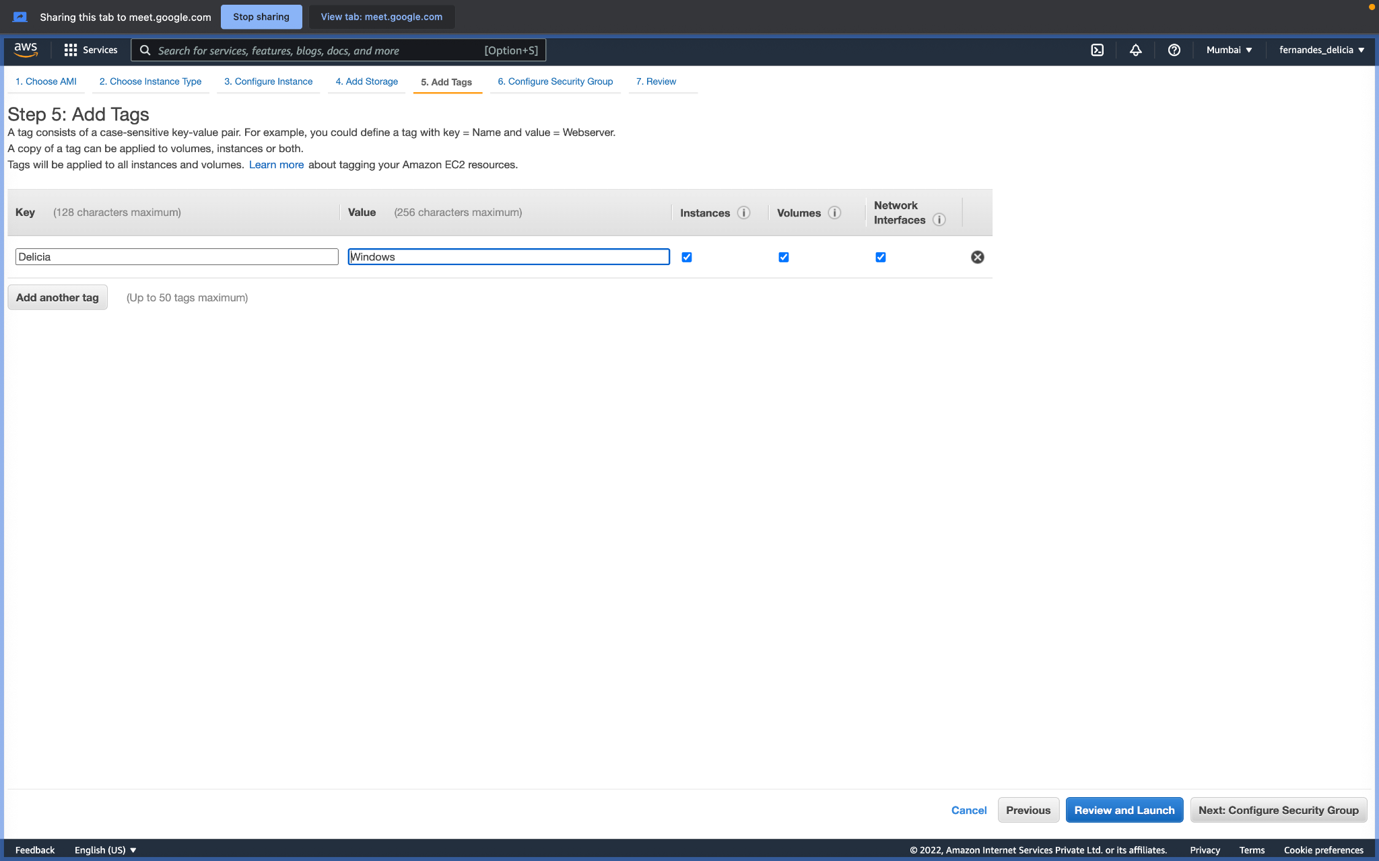

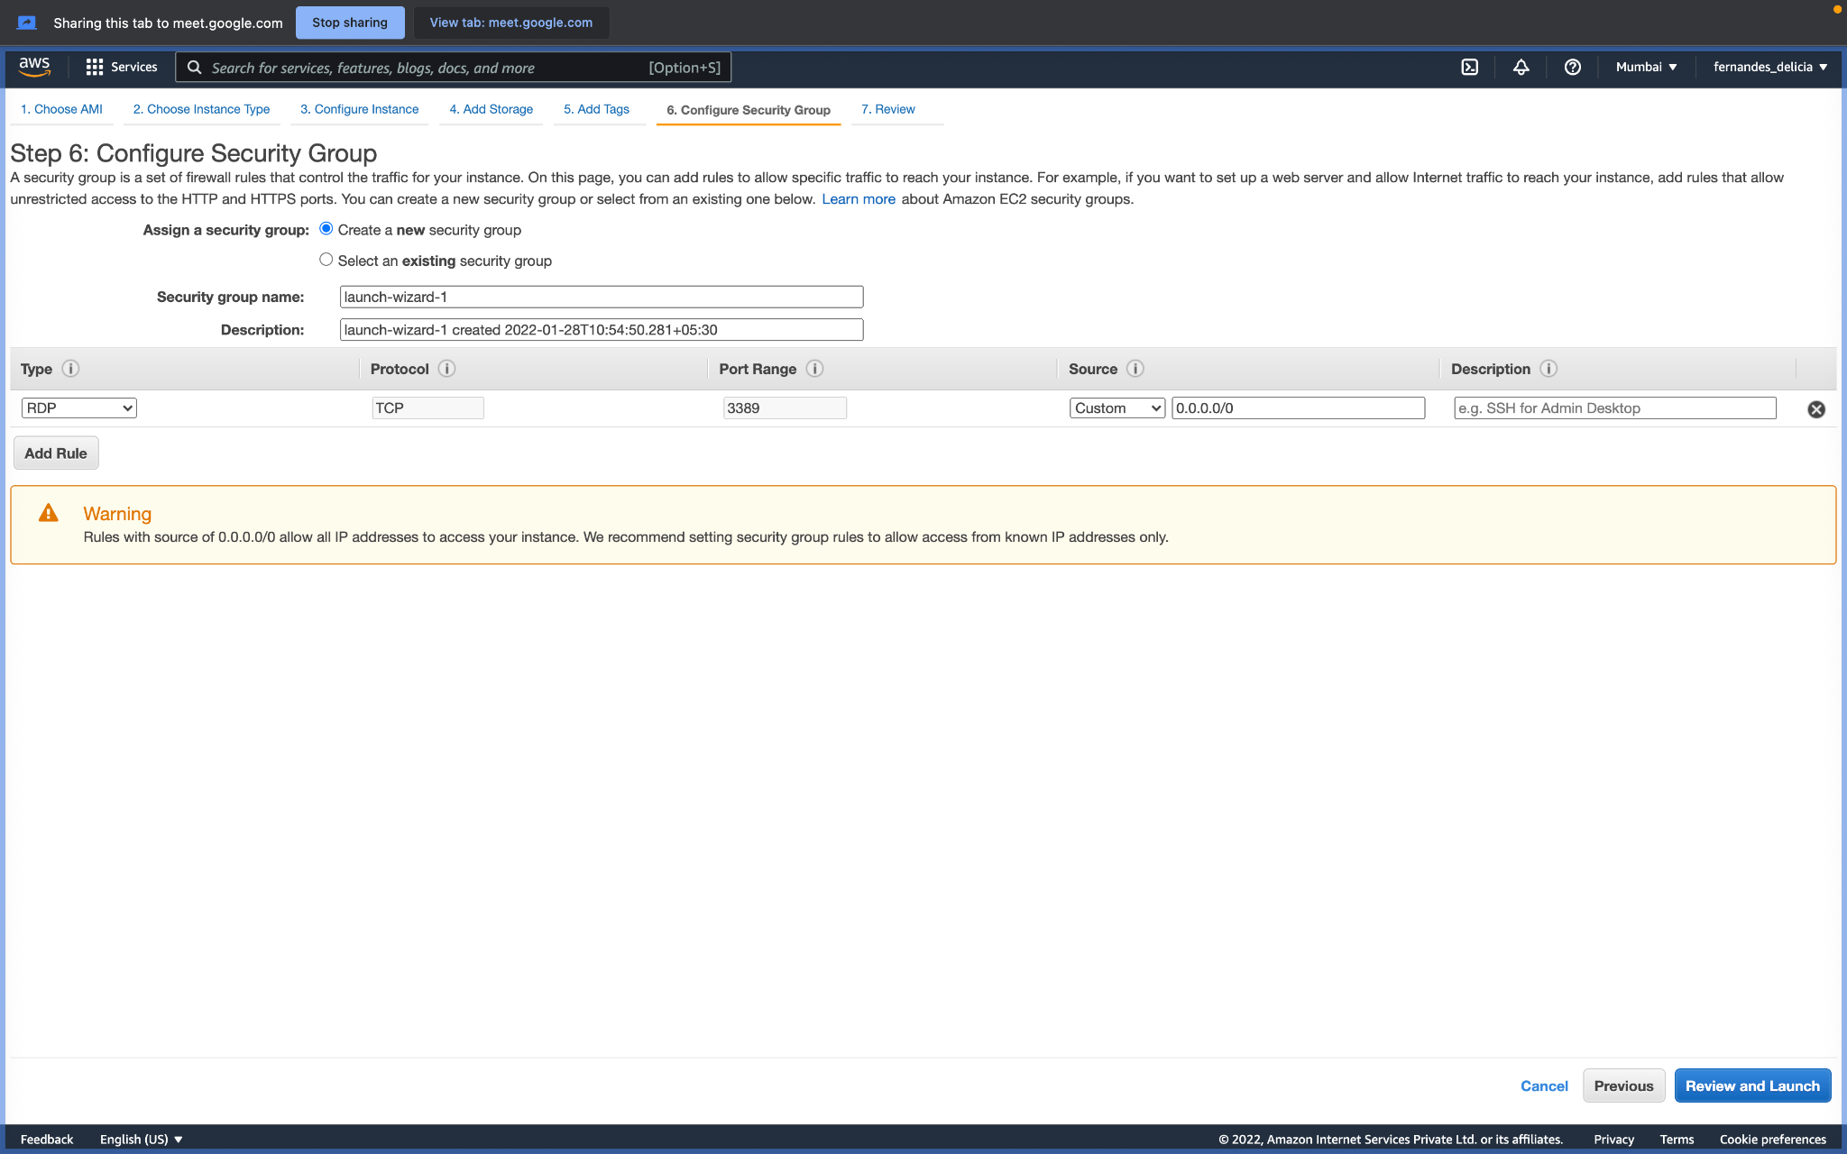

1. Download the rem file here, use it at the end

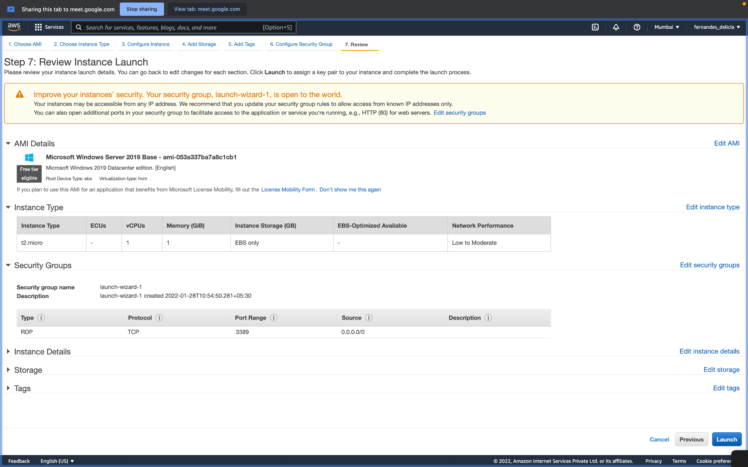

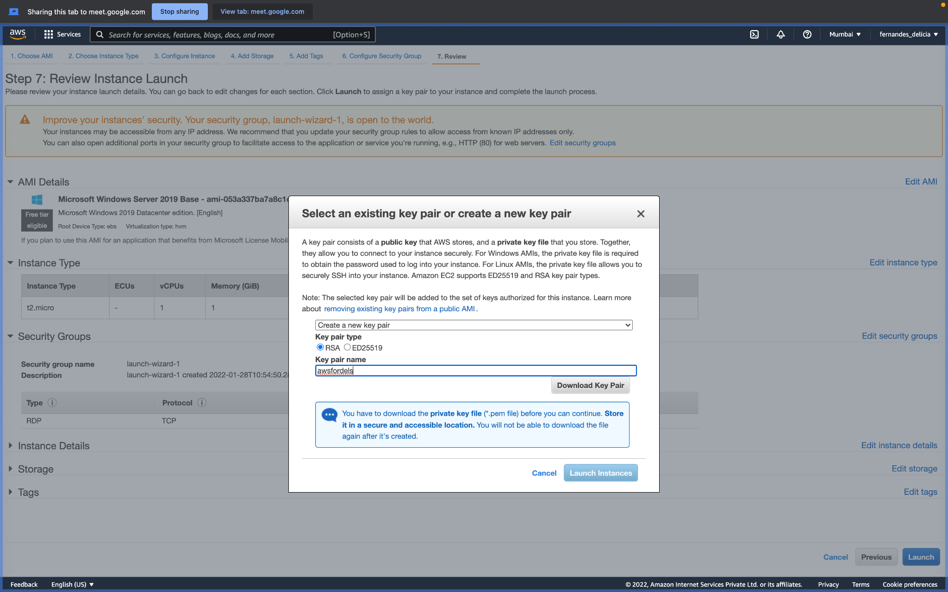

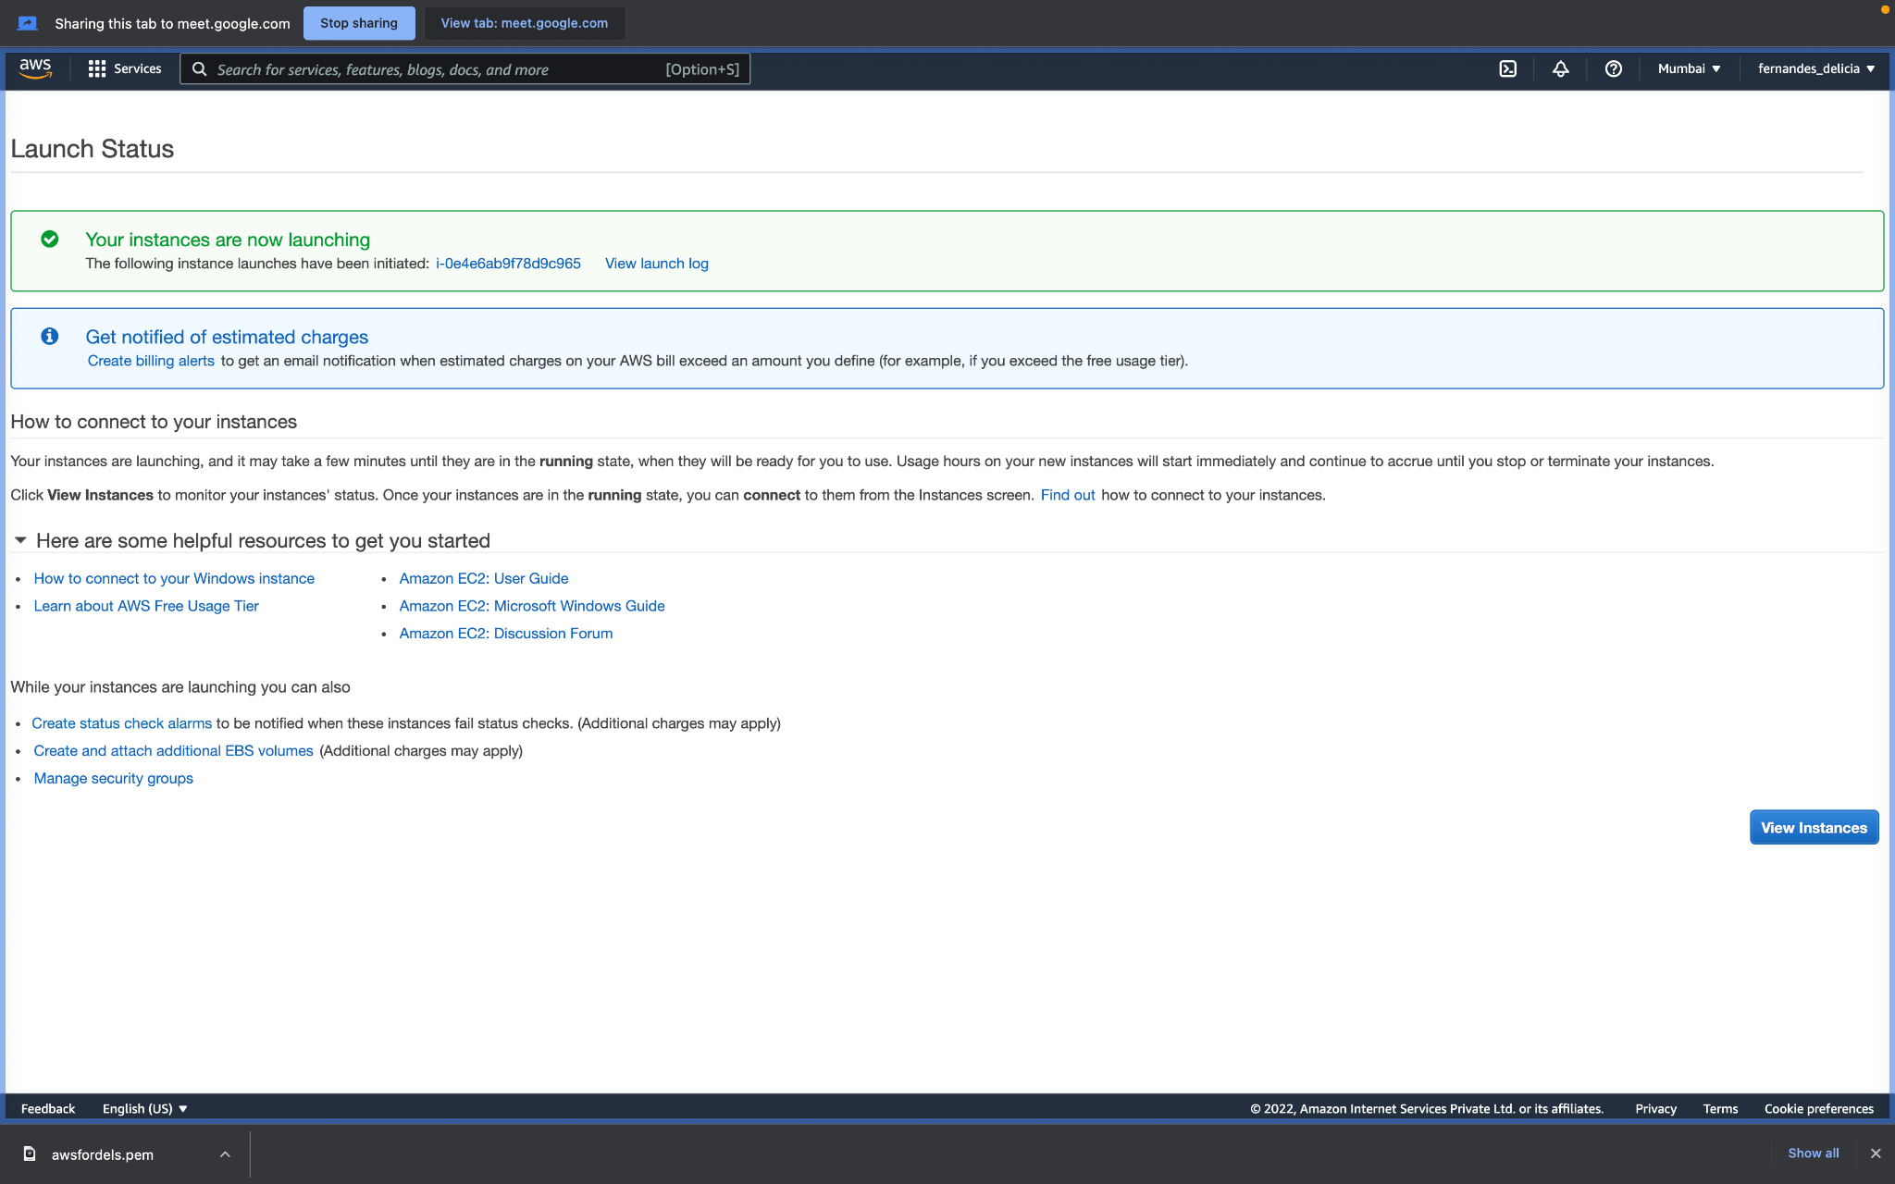

4. Wait for 2 mins, let it change from pending to running, then Click your instance here and click connect

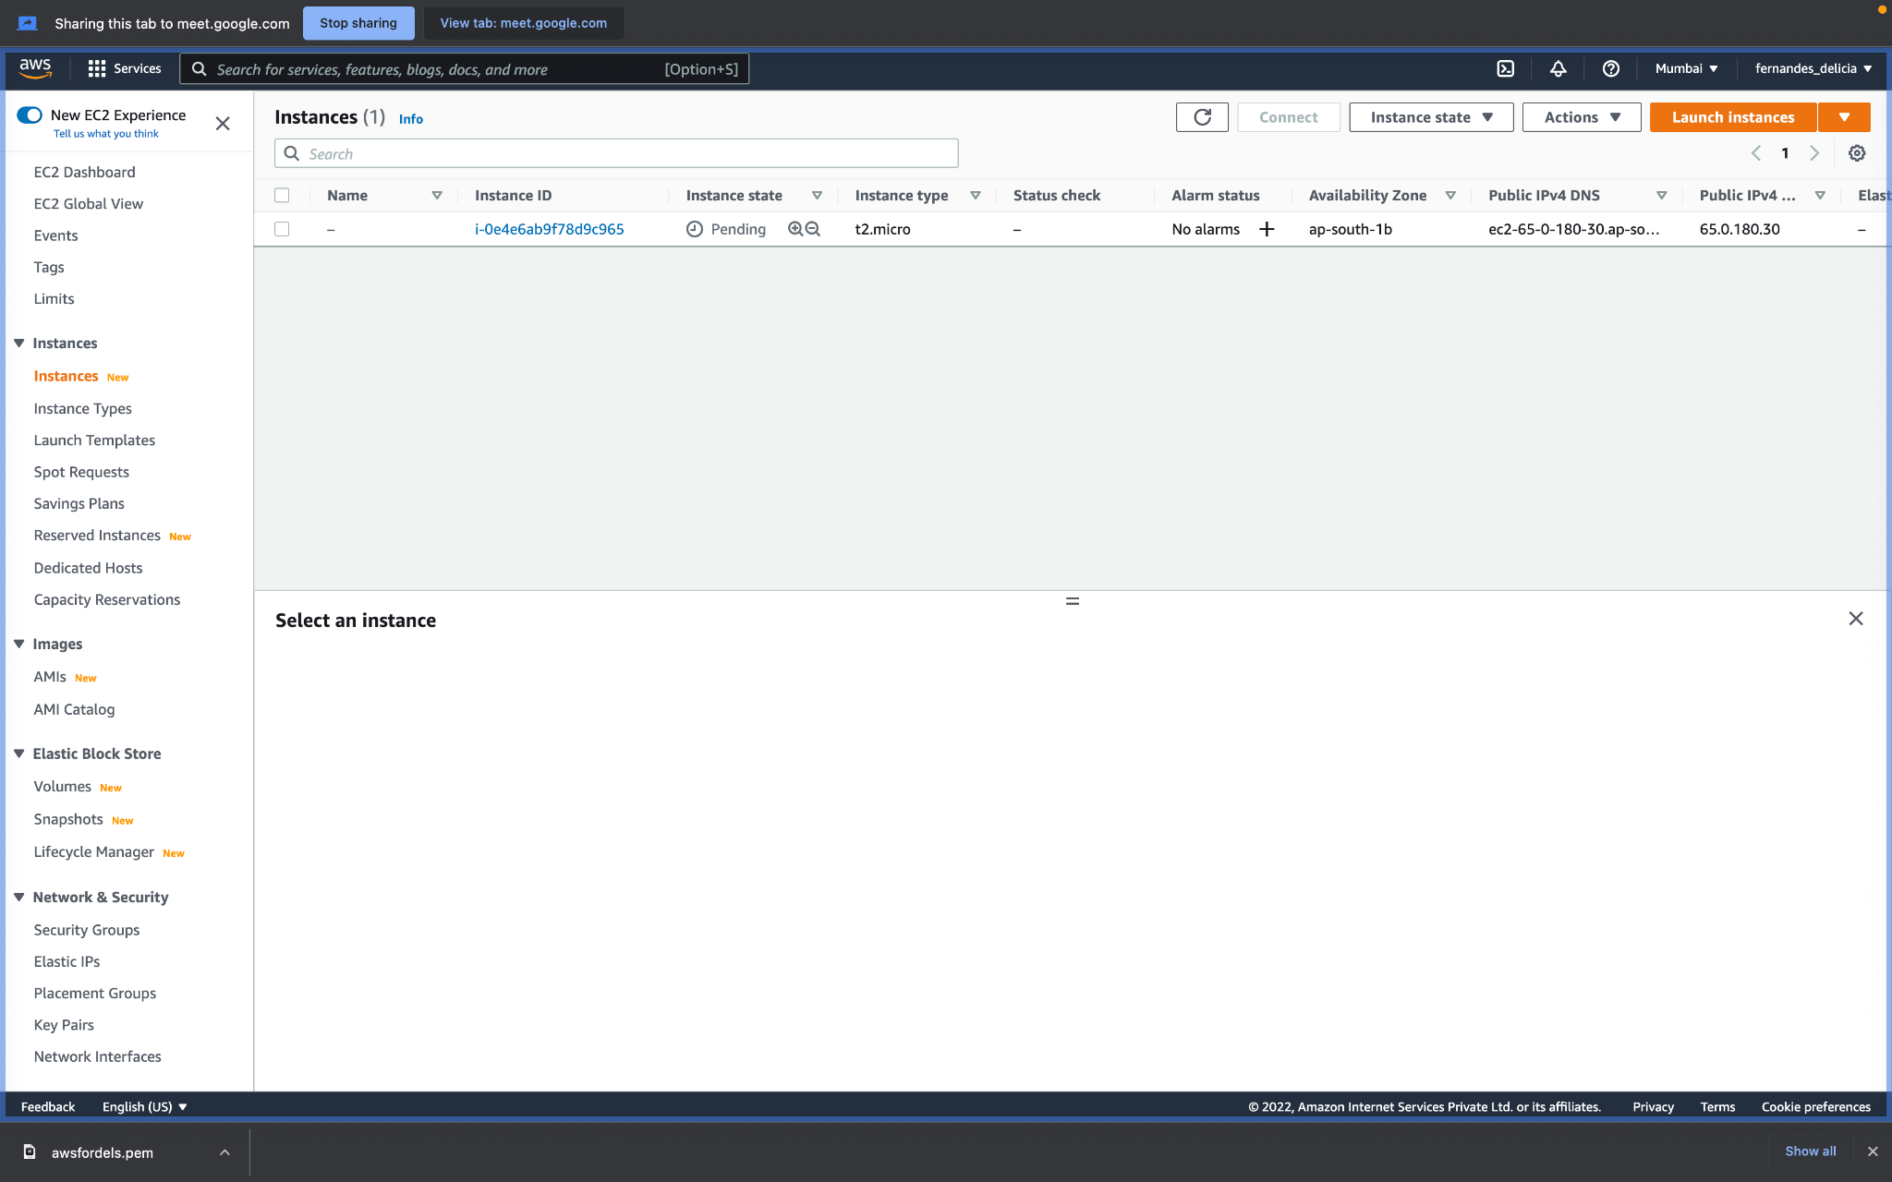

5. Download the rdp file here

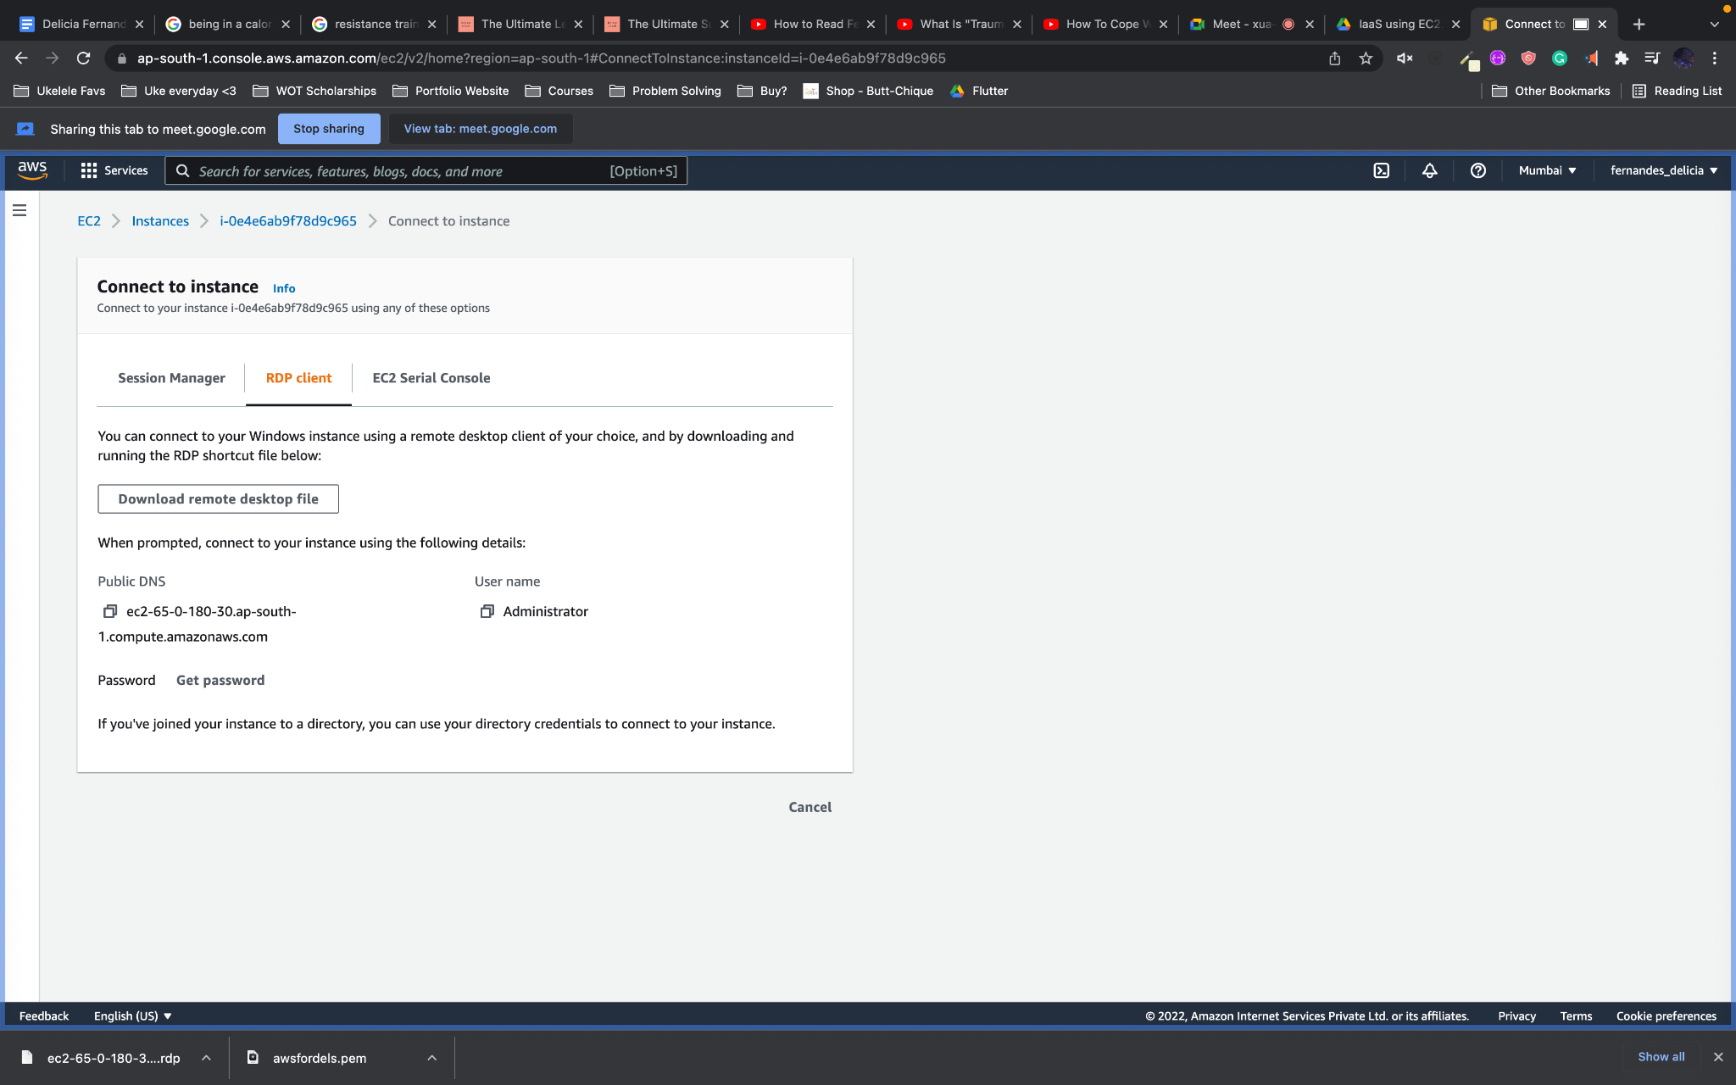

6. Upload the rem file here and decrypt

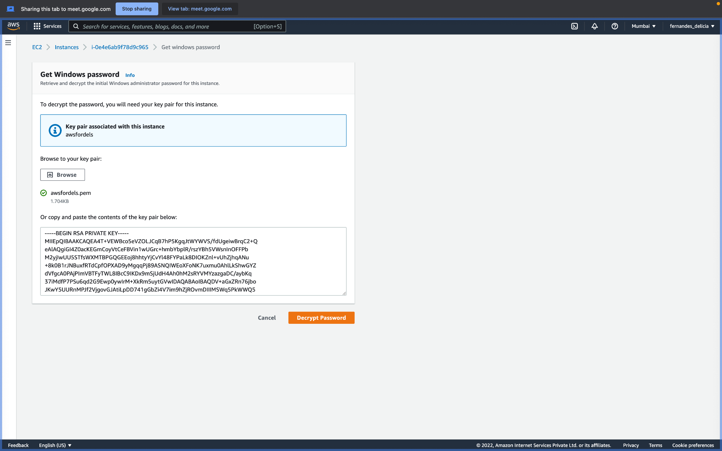

7. Copy this password and click on the RDP file on your local machine. Use the password there.

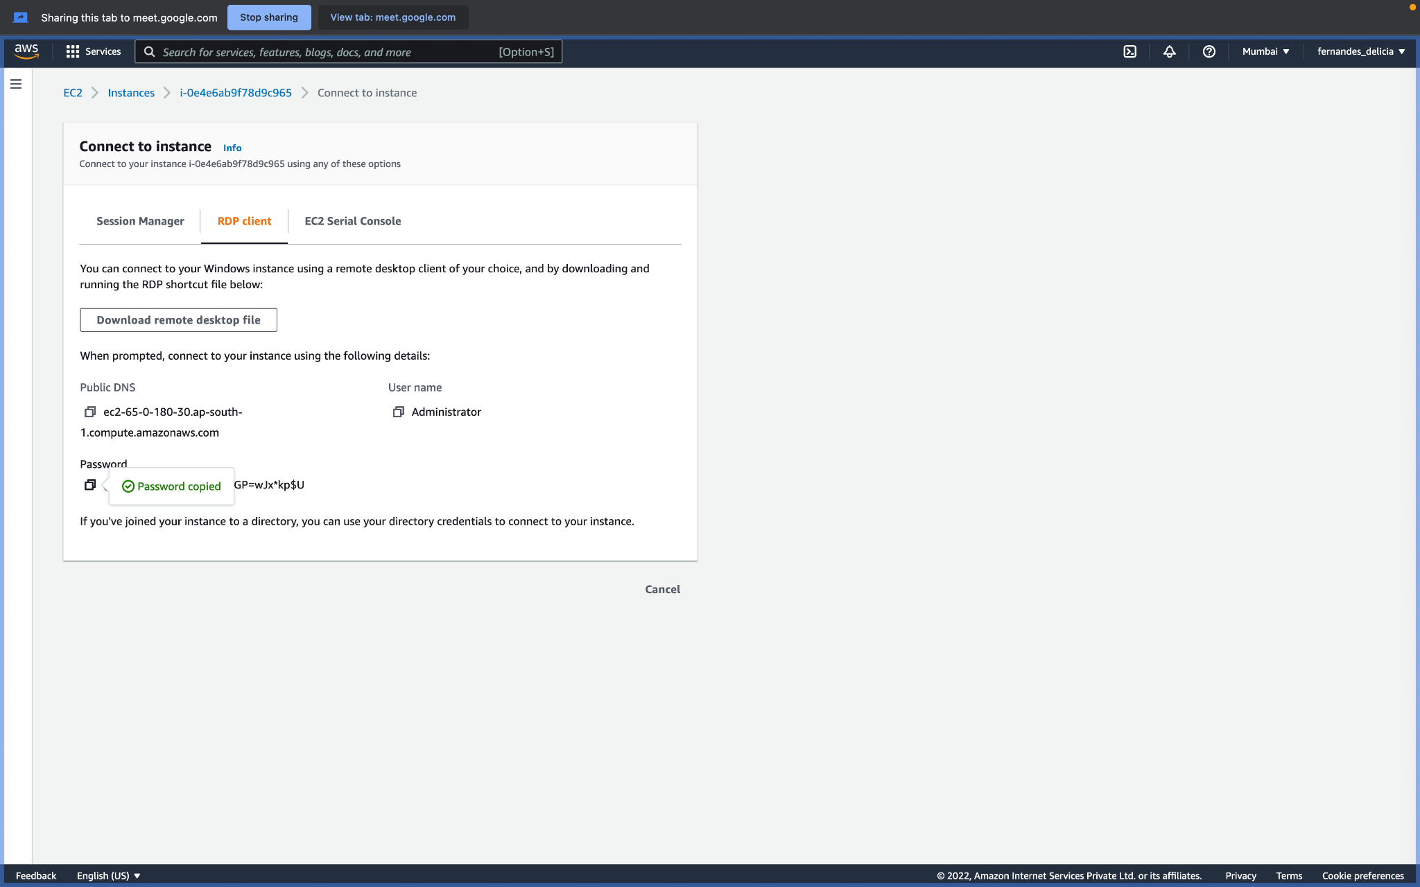

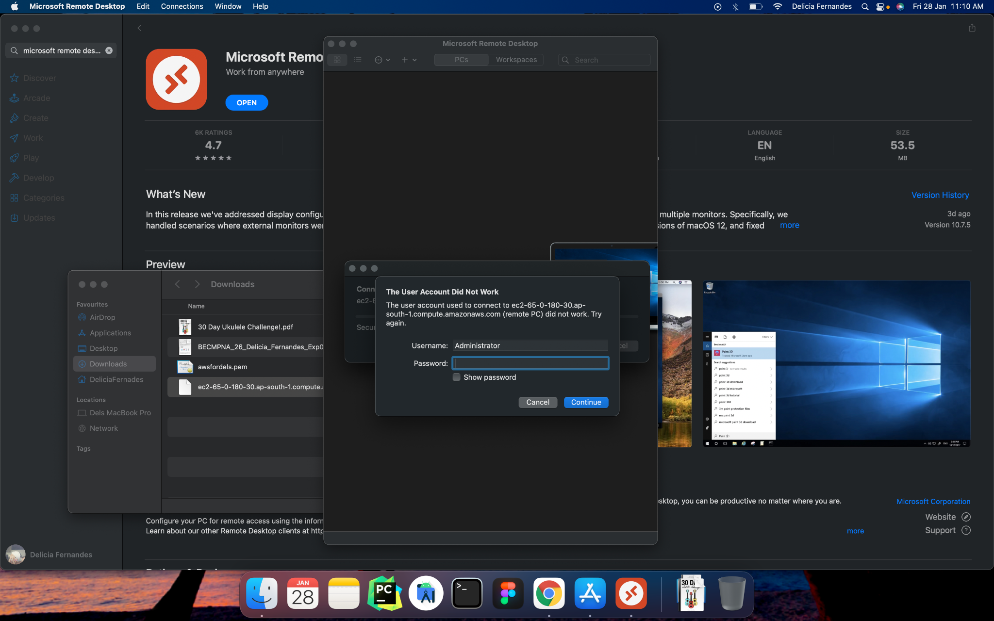

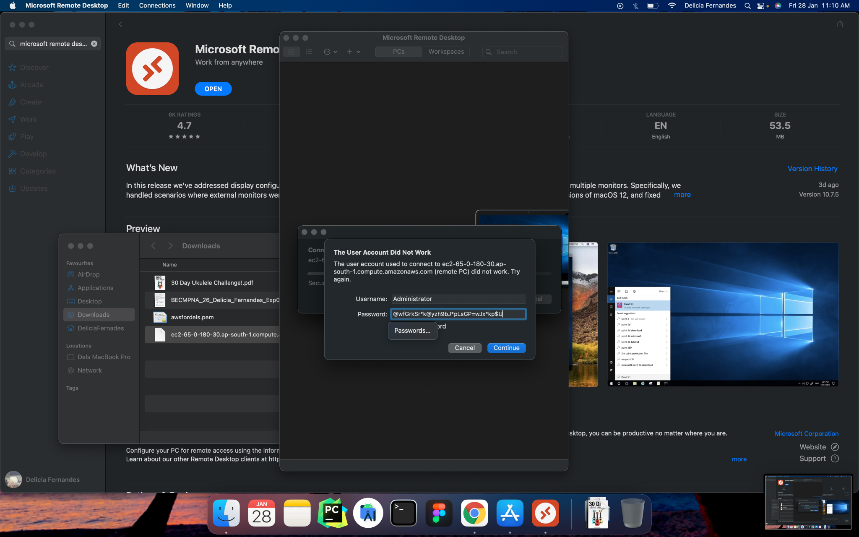





**Conclusion:**

What are the benefits of using IaaS?

Cost savings:

An obvious benefit of moving to the IaaS model is lower infrastructure costs. No longer do organizations have the responsibility of ensuring uptime, maintaining hardware and networking equipment, or replacing old equipment. IaaS also saves enterprises from having to buy more capacity to deal with sudden business spikes. Organizations with a smaller IT infrastructure generally require a smaller IT staff as well.

The pay-as-you-go model also provides significant cost savings. Because IaaS use is metered, organizations pay for only the capacity needed at any given time. This method also allows them to avoid large fixed monthly or annual fees for benefits they may not use. The IaaS model demands no upfront charges, bandwidth utilization fees or minimum term commitments.

Scalability and flexibility:

One of the greatest benefits of IaaS is the ability to scale up and down quickly in response to an enterprise’s requirements. IaaS providers generally have the latest, most powerful storage, servers and

Faster time to market:

Competition is strong in every sector, and time to market is one of the best ways to beat the competition. Because IaaS provides elasticity and scalability, organizations can ramp up and get the job done (and the product or service to market) more rapidly.

Benefits of IaaS Technology

* 1. [Increased Performance, Decreased CapEx](https://www.dataprise.com/resources/blog/iaas-benefits#One)
* 2. [Increased Security](https://www.dataprise.com/resources/blog/iaas-benefits#Two)
* 3. [Increased Scalability and Flexibility](https://www.dataprise.com/resources/blog/iaas-benefits#Three)
* 4. [Increased Support for Disaster Recovery and Business Continuity](https://www.dataprise.com/resources/blog/iaas-benefits#Four)

**References:**

[Infrastructure-as-a-Service: Benefits of IaaS Cloud Computing](https://www.dataprise.com/resources/blog/iaas-benefits)

[infrastructure-service-5-important-benefits](https://statetechmagazine.com/article/2014/03/infrastructure-service-5-important-benefits)

[IBM/lass](https://www.ibm.com/in-en/cloud/learn/iaas-paas-saas)

[Advantages and disadvantages of IaaS (Infrastructure as a Service) – Business Tech Planet](https://businesstechplanet.com/advantages-and-disadvantages-of-iaas-infrastructure-as-a-service/)